Microsoft Fabric in a Day Lab Manual – **Lab 3**

**Author**: Will Crayger

**Email**: [[wcrayger@lucidbi.co](mailto:wcrayger@lucidbi.co)](mailto:wcrayger@lucidbi.co)

**LinkedIn**: [LinkedIn.com/in/willcrayger/](https://www.linkedin.com/in/willcrayger/)

**Course Material**: [GitHub.com/Lucid-Will/FabCon-EU-Zero-To-Hero-with-Fabric](https://github.com/Lucid-Will/FabCon-EU-Zero-To-Hero-With-Fabric)

# Working with Pipelines – Extracting Source Data

## Introduction

## Copying data from source to target is a fundamental pattern in pipelines. To illustrate this, Lab 3 is divided into two parts, showcasing both basic and advanced applications of this approach:

## The first pipeline will extract data from a single table in an Azure SQL Database.

## The second pipeline will demonstrate a more advanced, real-world "metadata-driven" method, using a lookup activity to iterate through a list of tables and extract their data.

Understanding how lookups and parameters work together is key, as they enable the creation of powerful, scalable pipelines.

## Single Object Copy

**Create a Data Pipeline:** To begin creating your data pipeline, navigate to the **Data Engineering Fabric Landing** page. From here, choose **Data pipeline** from the available options. Name your pipeline **single_object_copy** and click **Create**.

**Setup the Copy Data Activity:** Once your pipeline is created, you'll land on the pipeline page. Select **Copy data** **assistant** to start the process. You will notice a variety of available data sources listed for data extraction. Choose **Azure SQL Database** from the list and click **Next**.

With the **Create new connection** option is selected, reauthenticate with the read-only credentials from lab 2 and click **Next**. In the table selection screen, check the box next to **Sales.Customers** and click **Next**.

**Selecting the Destination:** In the **Destination** menu, switch to the **OneLake data hub** tab located at the top of the window. Choose the **bronze_lakehouse** created in Lab 1 as the **Lakehouse** destination.

On the next page, change the table name to **sales_customers.** Review the other settings to familiarize yourself but leave everything as default and then click **Next**. You’ll be presented with the **Pipeline Summary**. Uncheck the **Start data transfer immediately** box. Click **OK** to save the configuration.

**Configuring and Running the Pipeline:** You should be returned to the canvas where the **Copy data** activity is visible. Select it and rename the activity to **single_object_copy** then select the **Source** tab to review the pre-populated configuration details that were set using the **Copy Data Tool**.

Next, select the **Destination** tab and review the settings there as well. For consistency, ensure the table name is lowercase, **sales_customers**. Expand the **Advanced** section and review the **Table action** options: **Append** and **Overwrite**. These are critically important depending on your project’s requirements.

Once you've reviewed everything, return to the **Home** tab of the pipeline and click the **Validate** button. If all steps were done correctly, no errors should appear, and you can safely close the **Pipeline Validation Output**.

**Executing and Monitoring the Pipeline:** Now that your pipeline is validated, click **Run** from the activity bar. Select **Save and Run** to begin the process. The **Output** of the pipeline will automatically display, allowing you to track the execution in real-time. You can also click on the **Activity Name** to launch the **Copy data details** blade, where you can monitor progress and review various metrics related to the run.

Once the pipeline is completed, navigate back to your **Lakehouse**. There, you should see the newly created table for **Sales_Customers**. You have now successfully completed **Part 1** of the lab.

## Part 2: Dynamic Object Copy

**Creating the Dynamic Object Copy Pipeline:** To begin, navigate to the **Data Engineering Fabric Landing** page. From there, choose **Data pipeline**. Name the pipeline **dynamic_object_copy** and click **Create**. Once the pipeline is created, click **Pipeline activity** from the landing page. We will start by executing a Lookupactivity to retrieve a list of schema and table combinations. From the list of activities, choose **Lookup** and add it to the canvas. Select the **Lookup activity** and rename it to **lookup_table_and_schema**.

**Configuring the Lookup Activity:** Navigate to the **Settings** tab of the Lookup activity and select the connection created in part 1 of this lab. Change the **Connection type** to **Azure SQL Database** and click the **Query** radial button. Now, locate the **Dynamic Load Source Query** file shared as part of the lab materials. Copy the query from the file and paste it into the **Query** box of the Lookup activity. Click **Preview Data** to see the output of the Lookup query and be sure to uncheck the box labeled **First row only**.

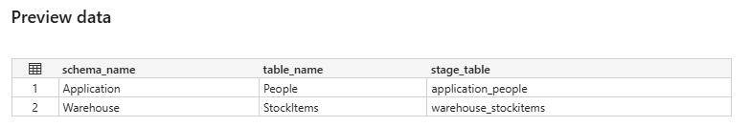

**Setting Up the ForEach Loop:** Next, open the **Activities** tab and add a **ForEach** activity to the pipeline canvas. Drag from the green checkmark on the **Lookup** activity to the **ForEach** activity to establish a connection between them. Select the ForEach activity and rename it **extraction_loop**. Go to the **Settings** tab of the ForEach activity, click inside the **Items** box, and select **Add dynamic content** to specify the items that will be looped through. Select **lookup_table_and_schema value array** from the list of activity outputs to populate the field, then click **OK**.

**Configuring the Copy Data Activity:** Once the ForEach activity is configured, click the **Pencil** icon to edit the loop’s contents. In the **Activities** tab, add a **Copy Data** activity to the canvas inside the loop. Select the **Copy Data** task and rename it **dynamic_object_copy**.

In the **Source** tab, set the connection to connection created in part 1, choose **Azure SQL Database** as the connection type, and check the **Enter Manually** box for the table query.

For the **Schema Name** field, click **Add dynamic content**, then select **extraction_loop** from the **ForEach iterator** options. Specify the **schema_name** field from the Lookup activity**,** confirming the expression reads **@item().schema_name**. Click **OK**. Repeat this process for the **Table Name** field, confirming the expression reads **@item().table_name**.

**Setting the Destination:** Navigate to the **Destination** tab of the **dynamic_object_copy** activity and select the **Lakehouse** created in **Lab 1**. In the **Table Name** field, click **Add dynamic content** to specify your **bronze lakehouse** (e.g, **bronze_lakehouse_wtc)** as the destination, ensuring the expression reads **@item().stage_table**. Open the **Advanced** menu and change the table action to **Overwrite**.

**Validating and Running the Pipeline:** Return to the **Home** tab of the pipeline and click **Validate** to ensure that there are no errors in the setup. Once the validation is complete, click **Run** from the activity bar to execute the pipeline. You can monitor the pipeline run in the **Output** tab, where you’ll notice multiple **Copy** activities running simultaneously.

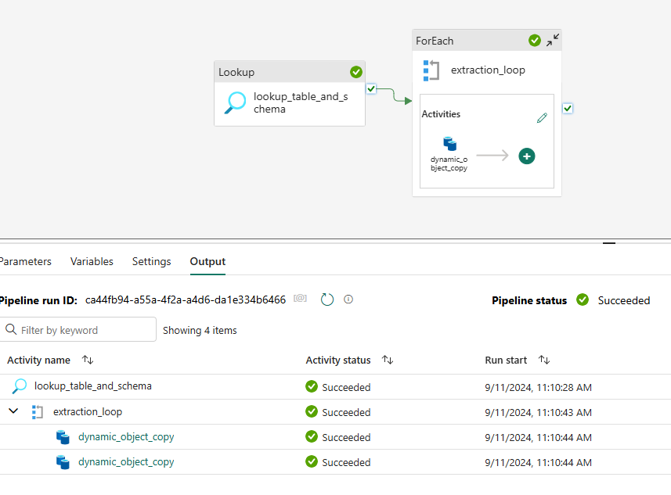

**Confirming the Results:** After the pipeline run completes, navigate back to your **Lakehouse** to confirm that the delta tables have been created. If the tables aren’t immediately visible, refresh your browser or right-click on **Tables** and select **Refresh**.

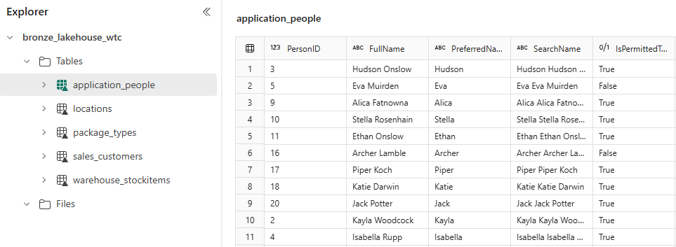

You have now successfully completed **Part 2** of the lab.